ASSIGNMENT - 3

By Karthikeyan K R

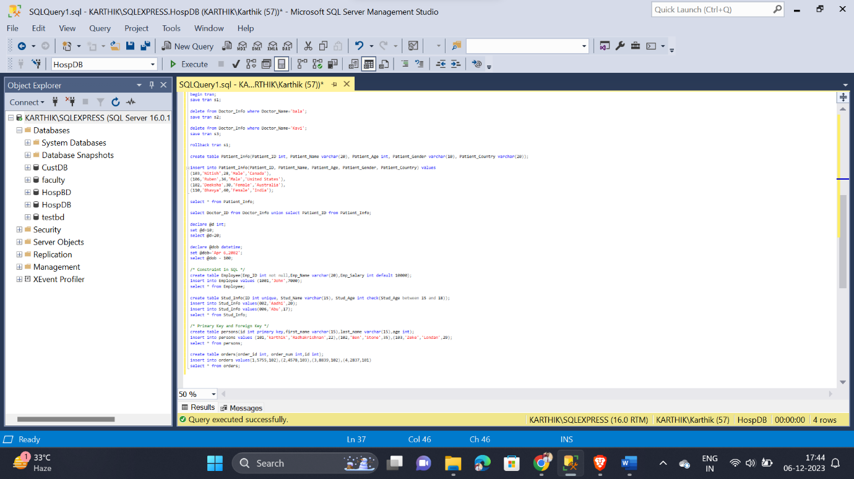

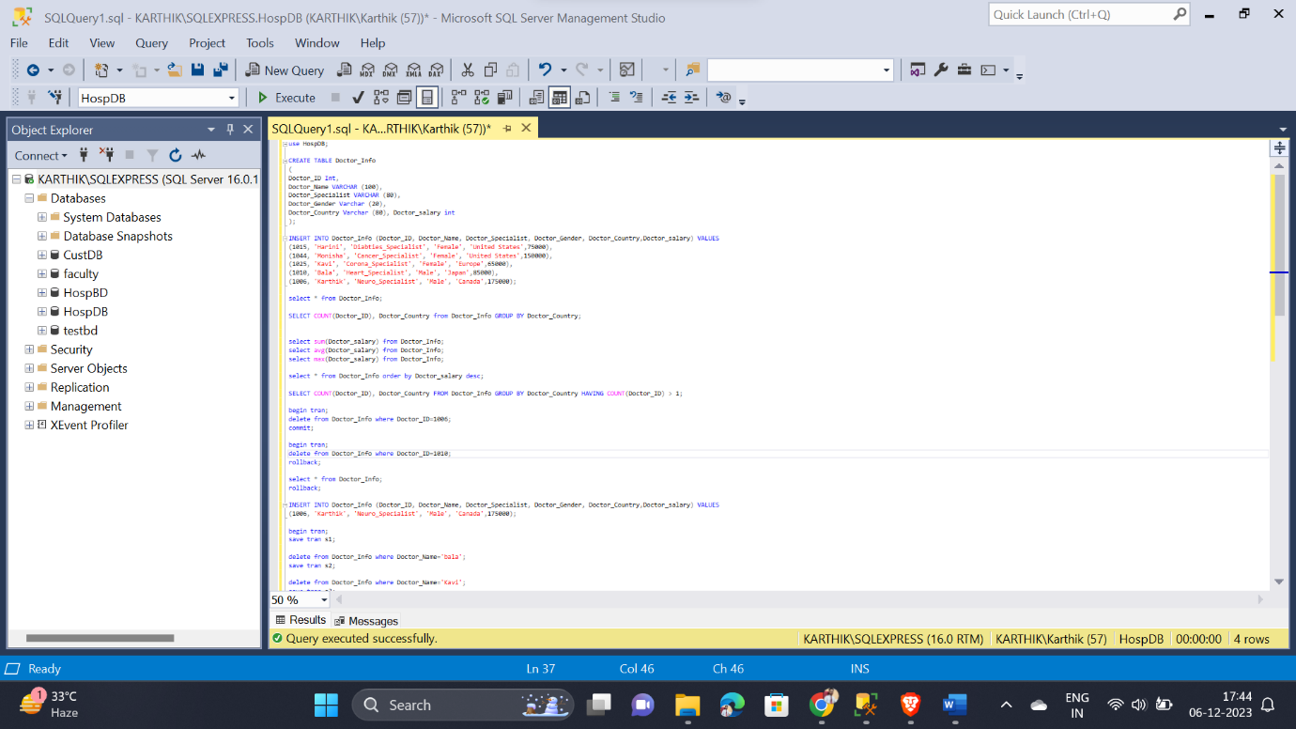

* In today’s assignment practised Group by and Having clause
* Then Completed Aggregated Functions – SUM, AVG and MAX
* Made a query and executed for order condition
* Then completed Transactions commands like COMMIT, ROLLBACK and SAVEPOINT
* Performed Arithmetic operations using queries
* Then practised Constraint statements
* Finally made a query and executed on Primary Key and Foreign Key